**Create a template using VS code**

1. Open VS code
2. Left top there is a file menu open it create a new folder.

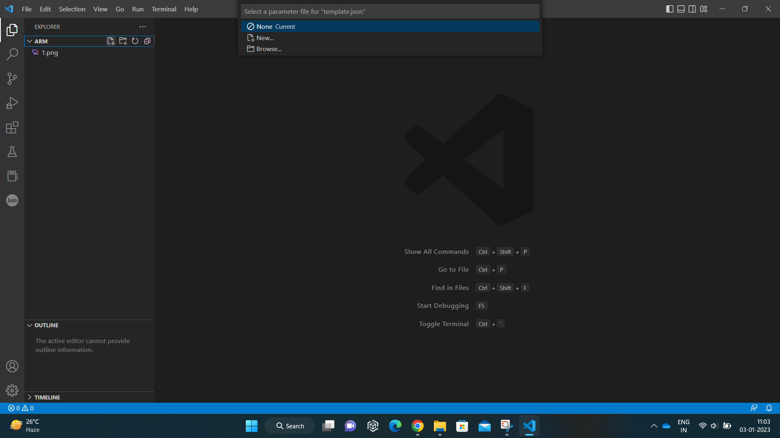

1. Create a new file with Json extension. Example: template.json

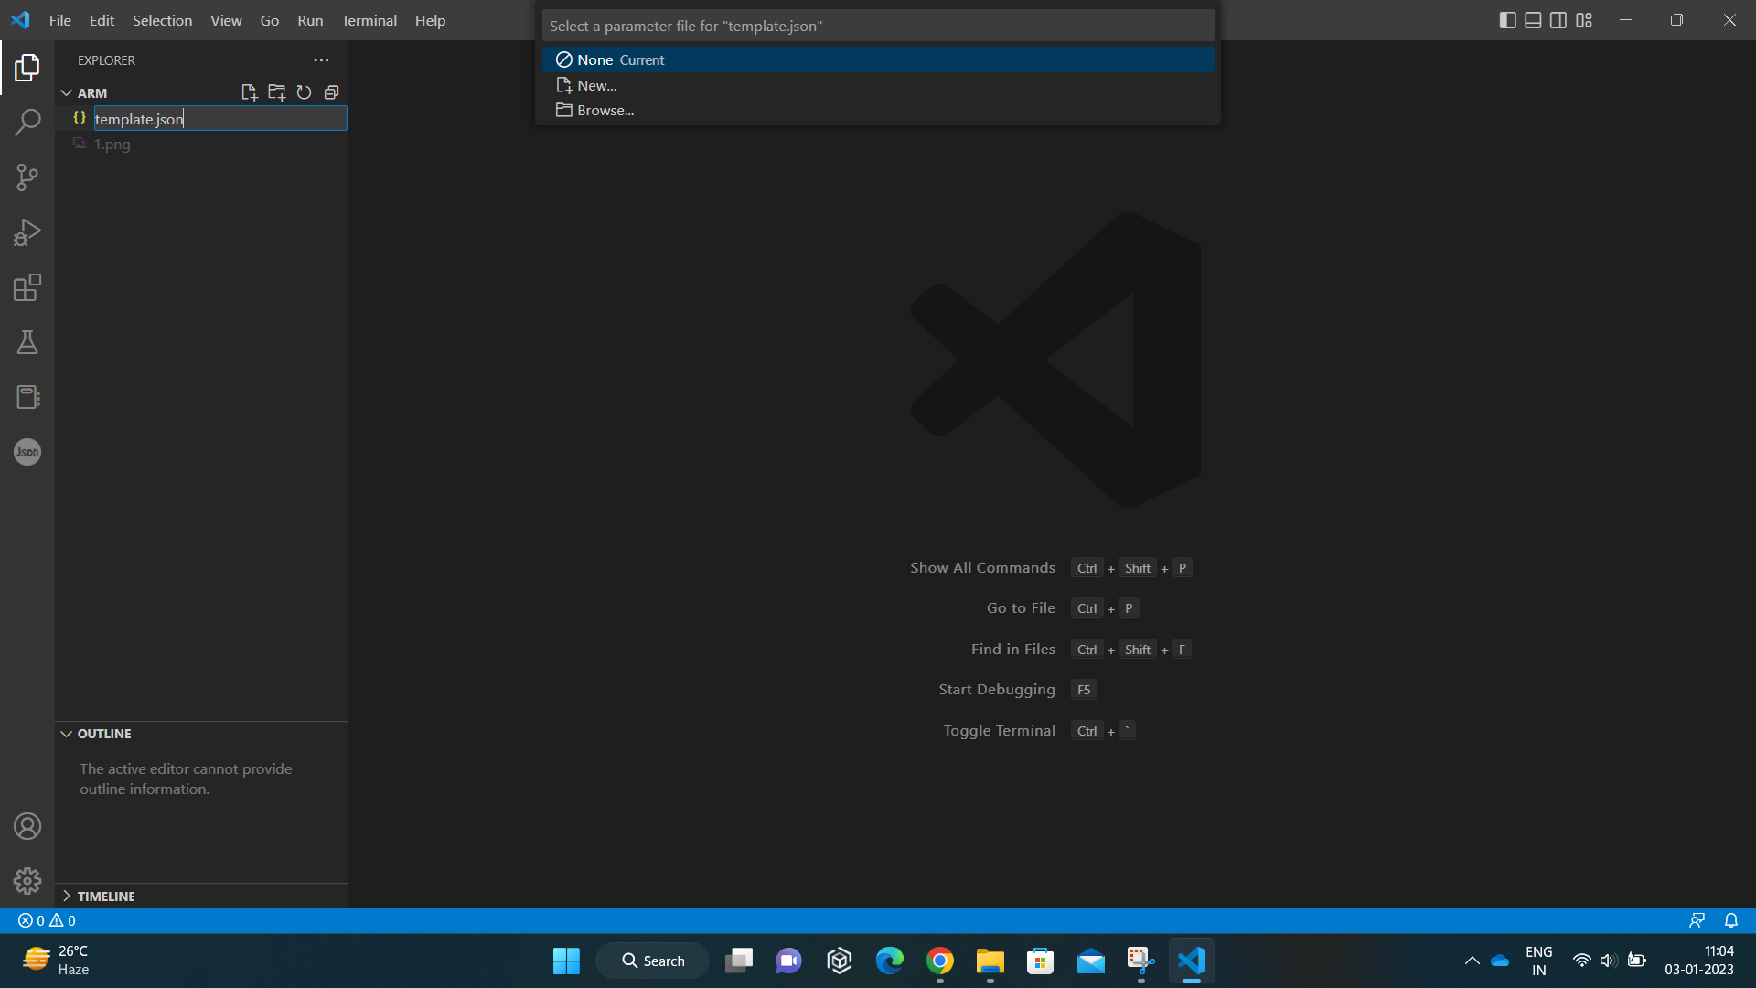

1. Now we are going to create a template start typing arm and select the arm!

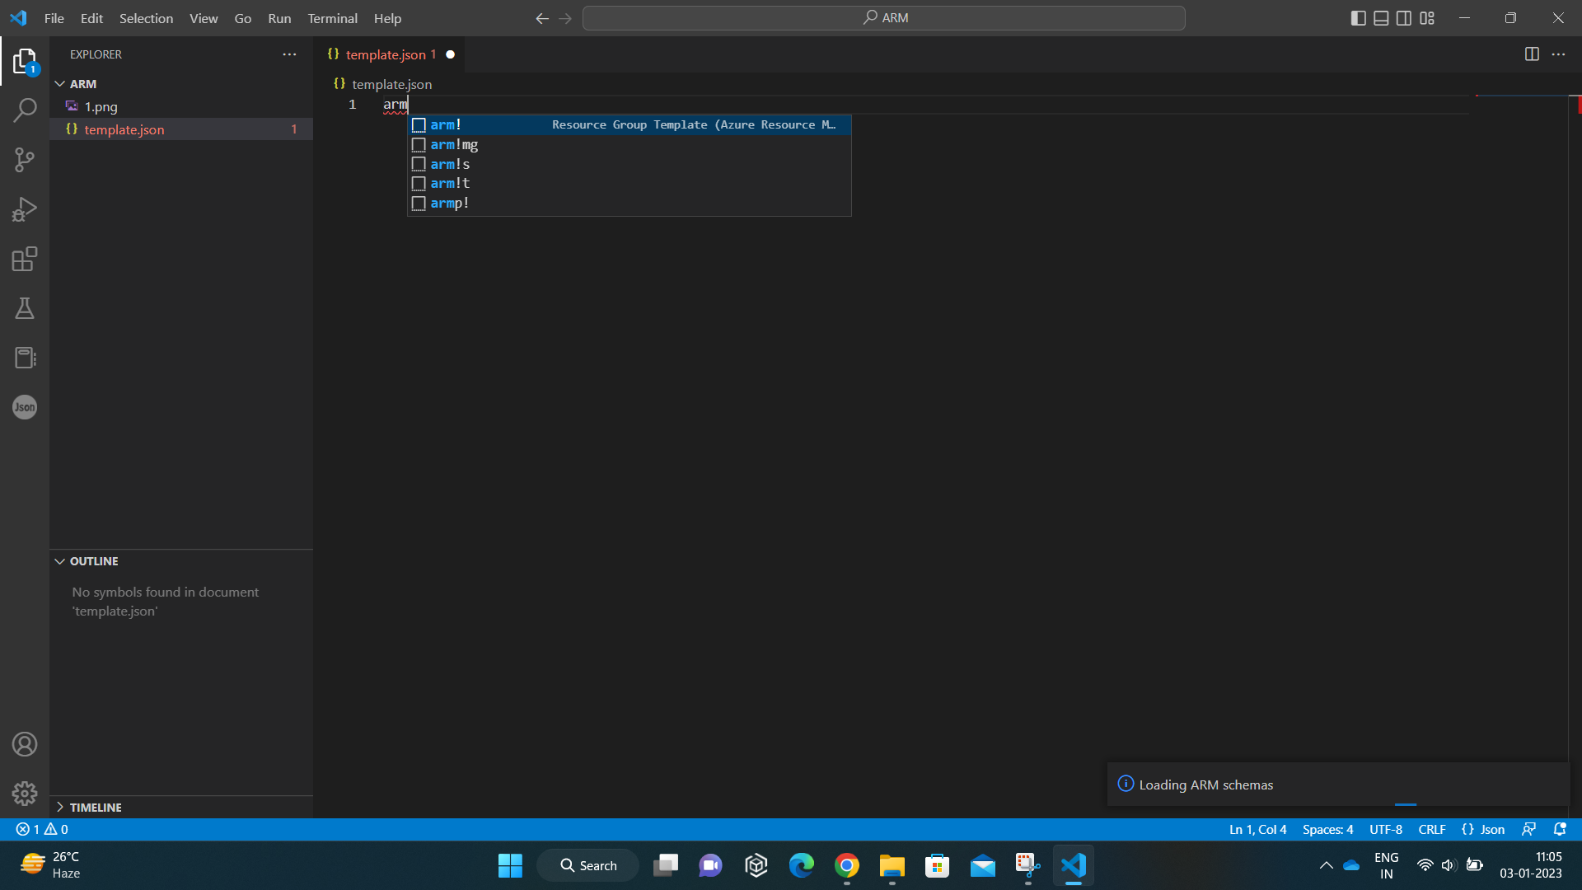

1. Automated code will generate.
2. In line 7 resources we are going select which resource we are going to create
3. For example: we are going to create storage account. Start typing storage in empty brackets a drop down will open select the arm- storage.

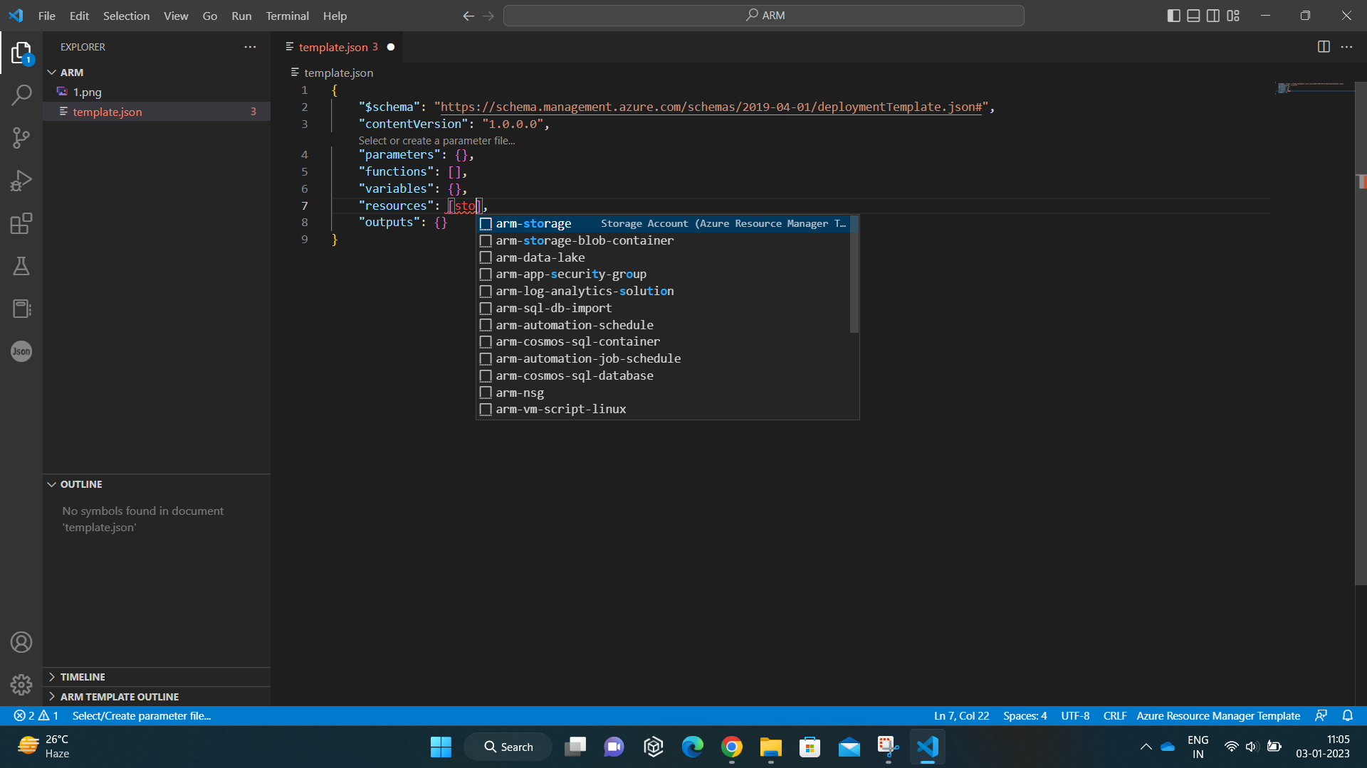

1. Automated code will generate.

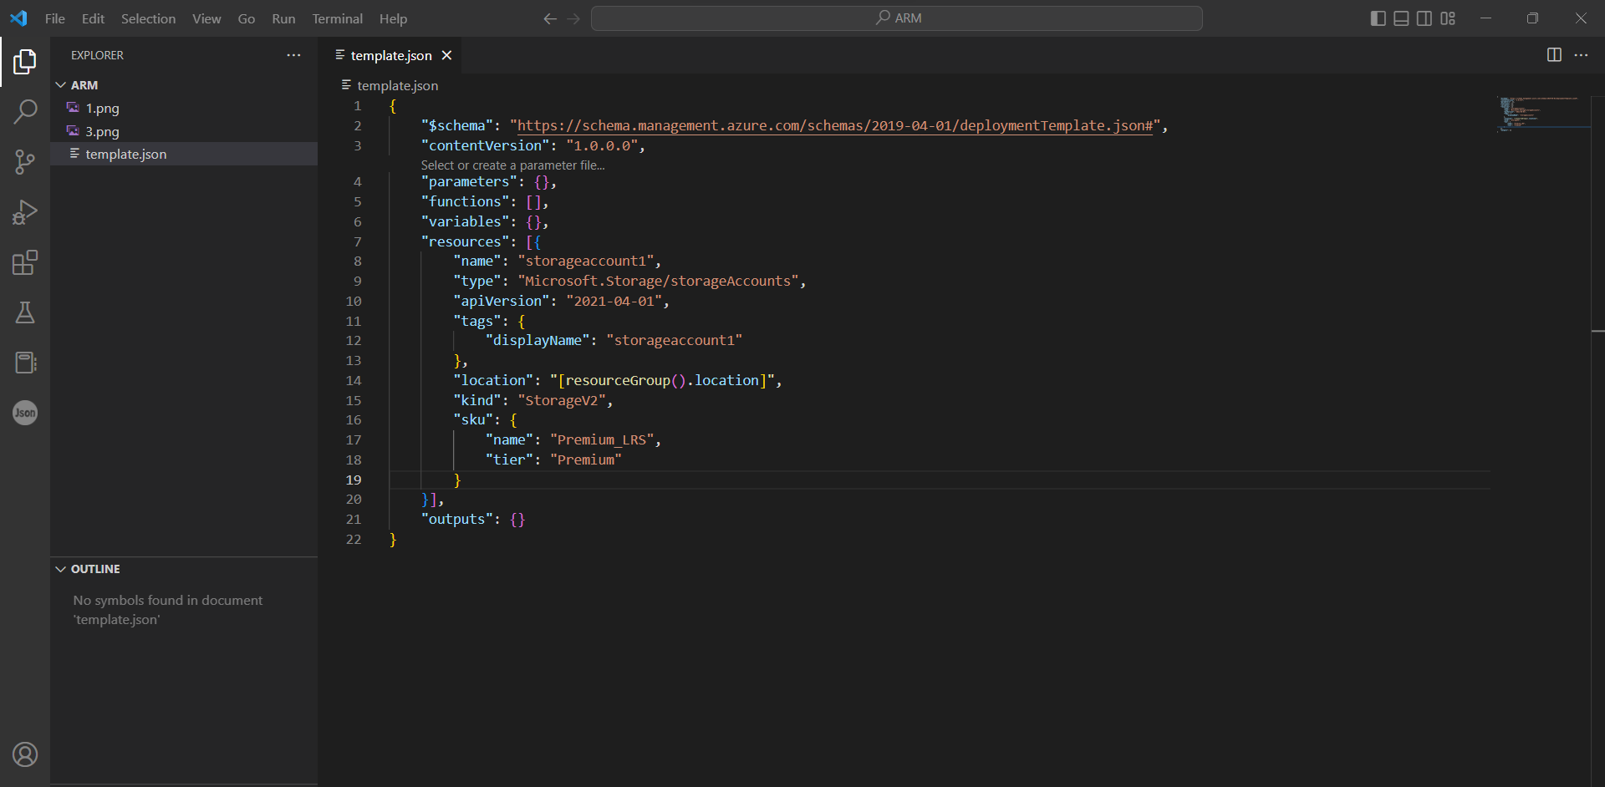

1. Now Change the Storage account name. In line number 8 and line number 12. The storage account name is unique in the selected region.

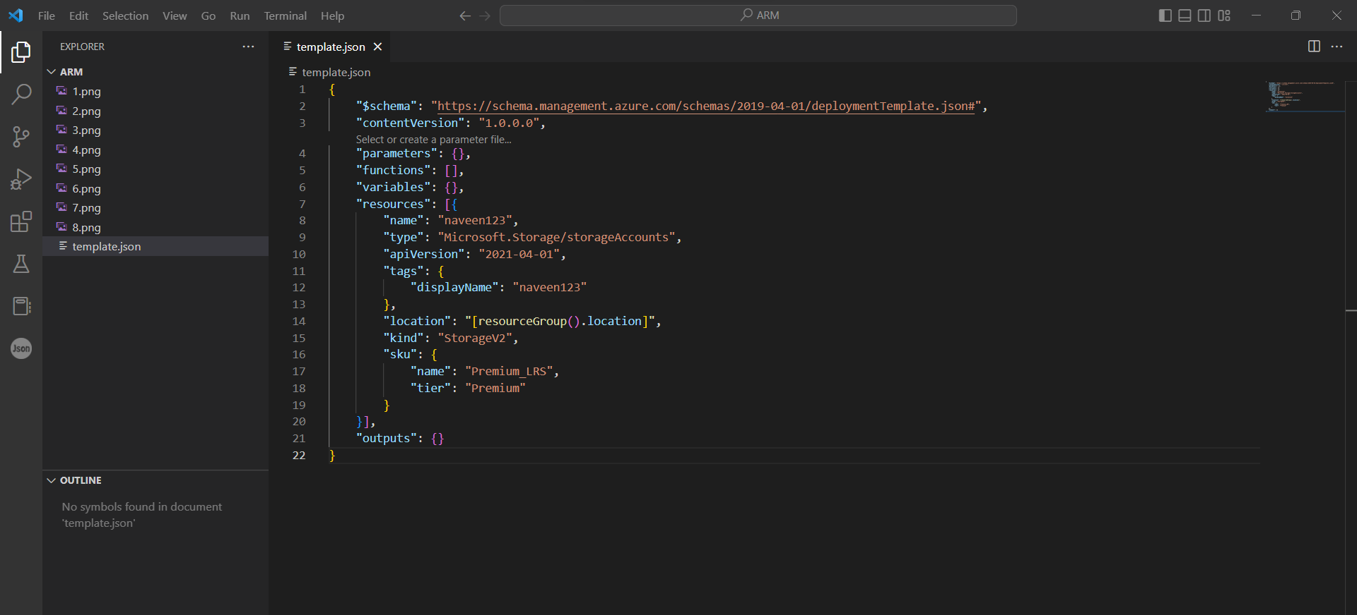

1. Now open the AZURE portal. Search for deploy a custom template. Open the resource.
2. Click on Build your own template in the editor.

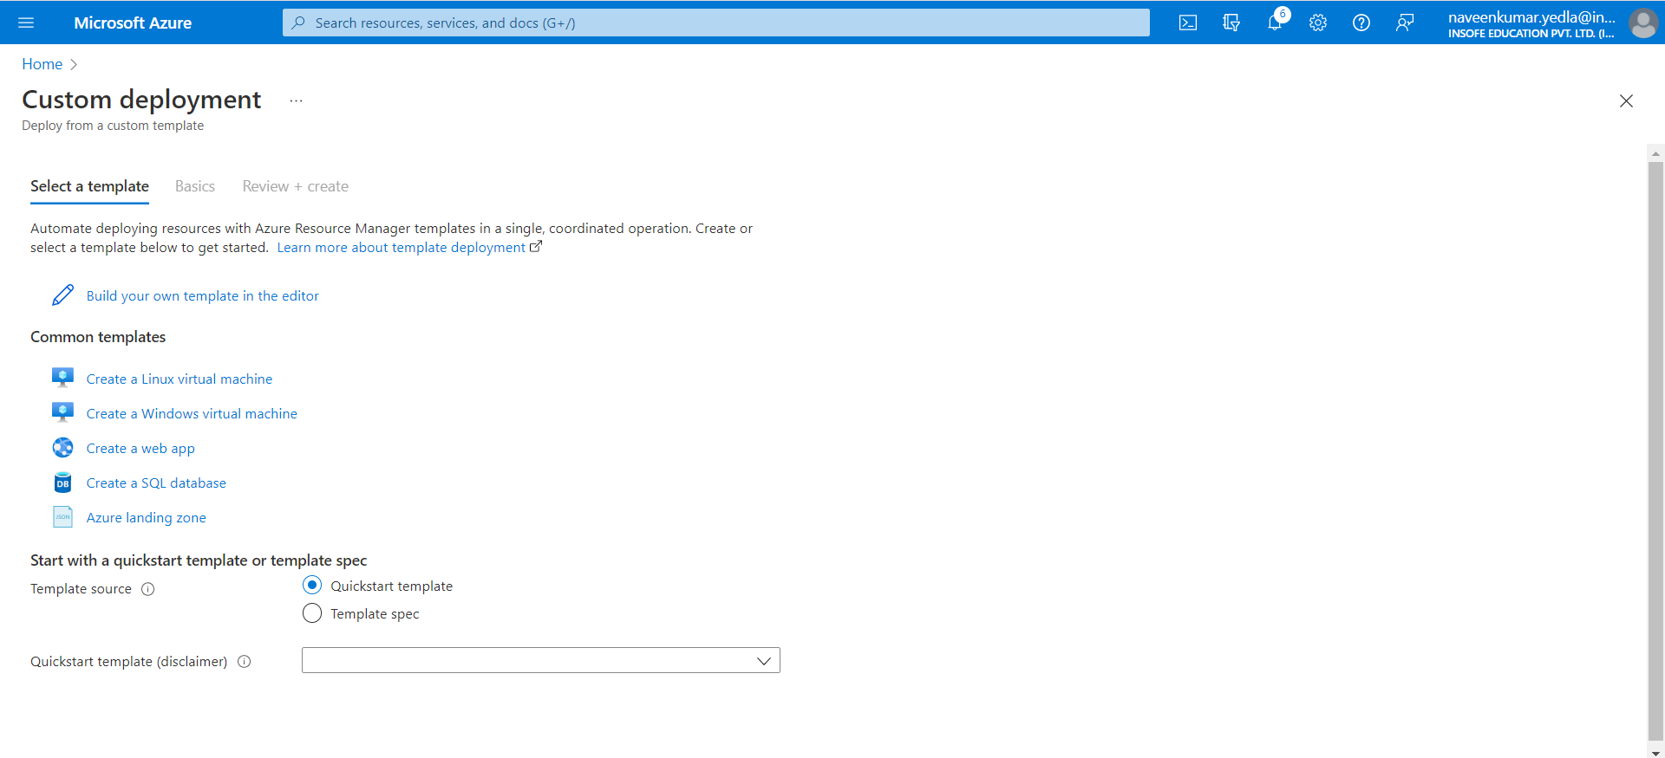

1. Copy the code from VS code and paste it.
2. Save the code.

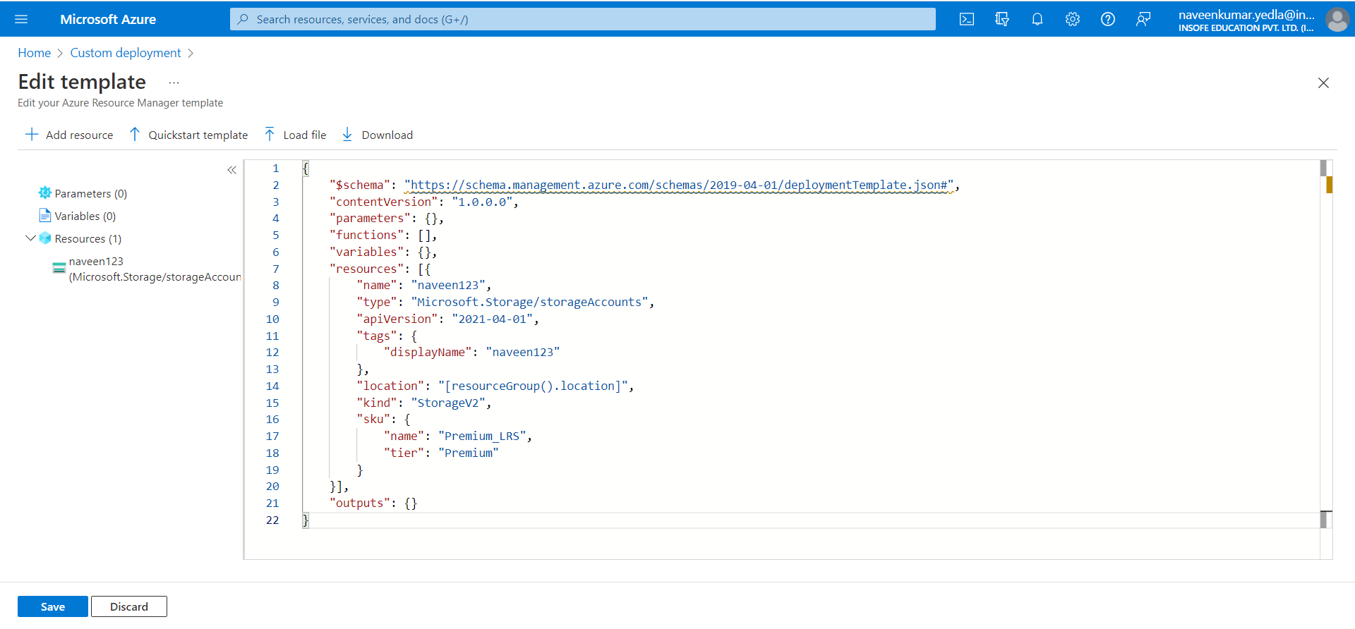

1. Go to Basics tab. Select the azure Subscription.
2. Resource group if exist select it otherwise create a new resource group.
3. Click on review + create.

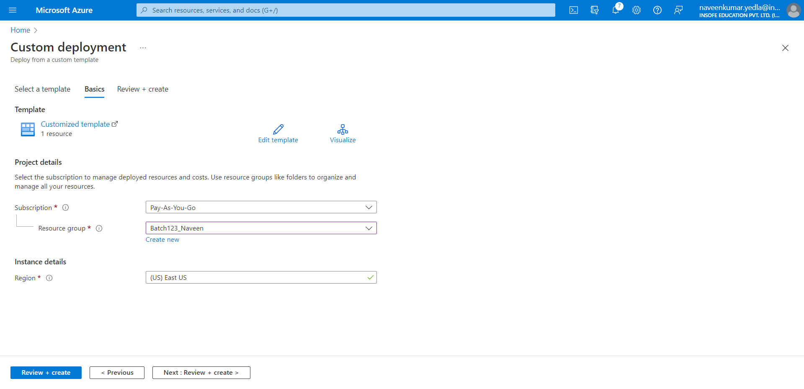

1. Click on create. It will take few seconds to deploy the resource.

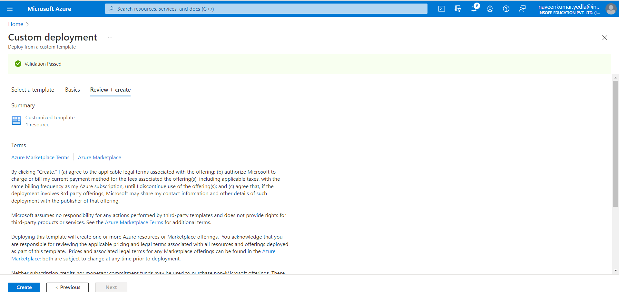

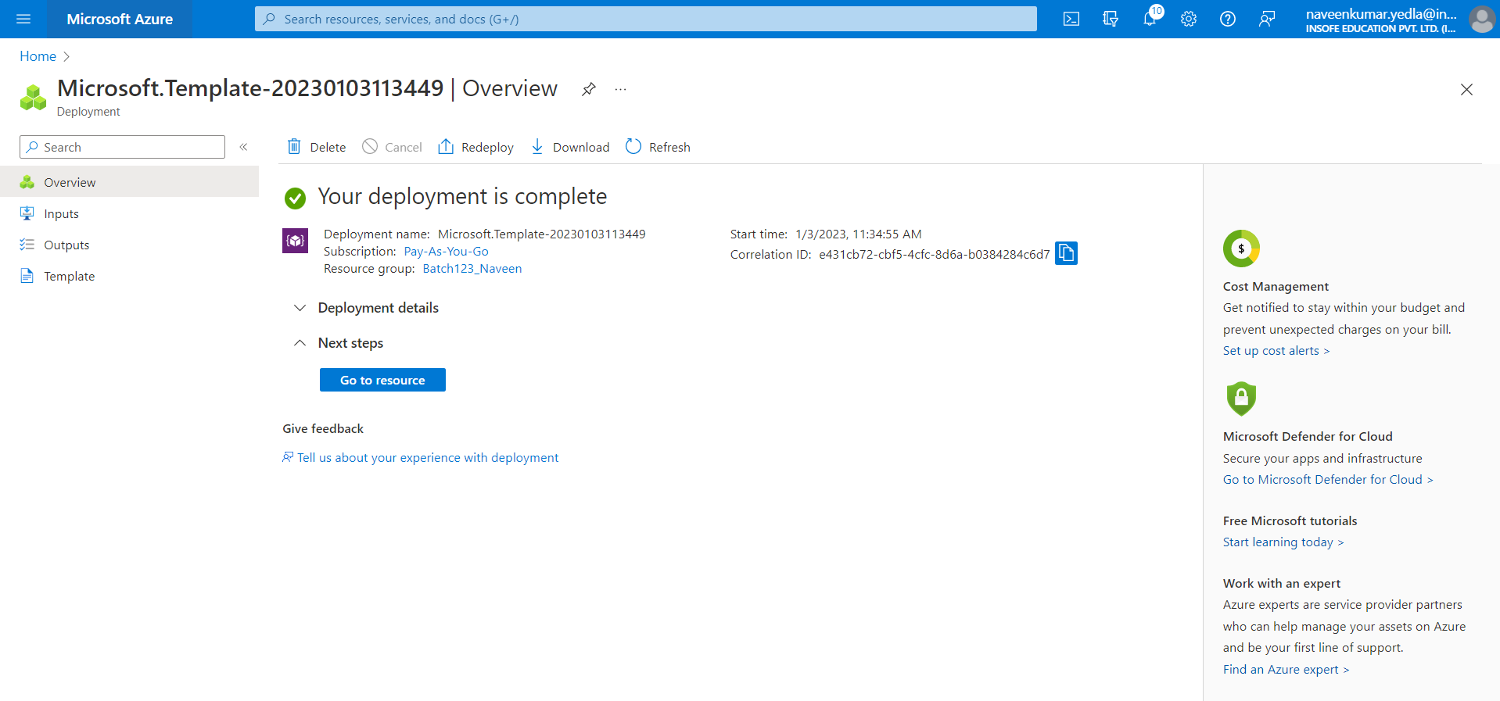

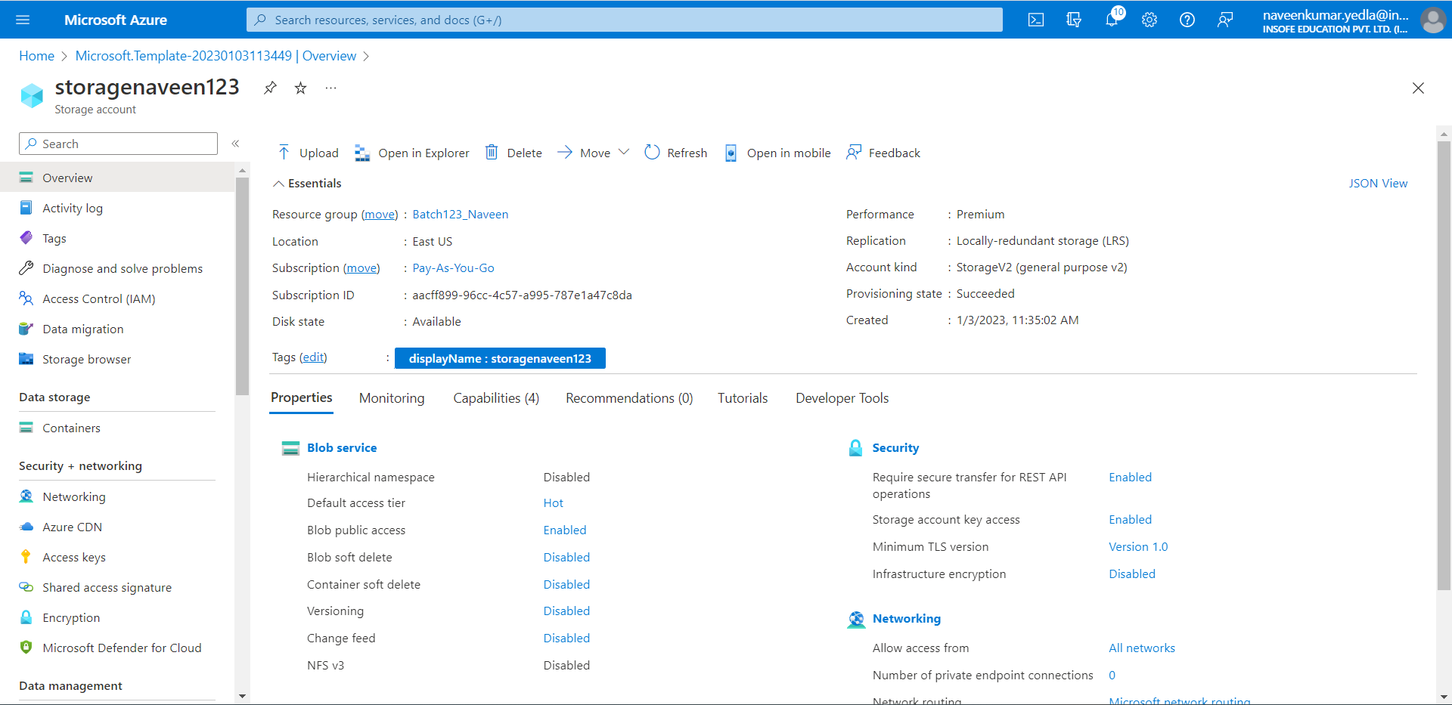**Clean up resources**

In the overview tab delete the template and also delete the resource group.